**Batch: Roll No.:**

**Experiment / assignment / tutorial No. 9**

|  |
| --- |
| **Title: Implementing indexing and query processing** |

**Objective:** To understand Query Processing and implement indexing to improve query execution plans

**Expected Outcome of Experiment:**

CO 3: Use SQL for relational database creation , maintenance and query processing

**Books/ Journals/ Websites referred:**

1. Dr. P.S. Deshpande, SQL and PL/SQL for Oracle 10g.Black book, Dreamtech Press

2. www.db-book.com

3. Korth, Slberchatz, Sudarshan : “Database Systems Concept”, 5th Edition , McGraw

Hill

4. Elmasri and Navathe,”Fundamentals of database Systems”, 4th Edition,PEARSON

Education.

**Resources used:** PostgreSQL/MySQL

**Theory:**

A database index is a data structure that improves the speed of operations in a table. Indexes can be created using one or more columns, providing the basis for both rapid random lookups and efficient ordering of access to records.

While creating index, it should be taken into consideration which all columns will be used to make SQL queries and create one or more indexes on those columns.

To add an index for a column or a set of columns, you use the CREATE INDEX statement as follows:

CREATE INDEX index_name ON table_name (column_list)

Query life cycle

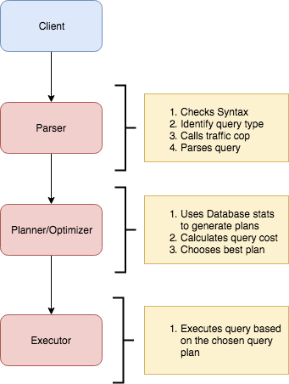

### Planner and Executor:

The planner receives a query tree from the rewriter and generates a (query) plan tree that can be processed by the executor most effectively.

The planner in Database is based on pure cost-based optimization -

**EXPLAIN command:**

This command displays the execution plan that the PostgreSQL/MySQL planner generates for the supplied statement. The execution plan shows how the table(s) referenced by the statement will be scanned — by plain sequential scan, index scan, etc. — and if multiple tables are referenced, what join algorithms will be used to bring together the required rows from each input table.

As in the other RDBMS, the EXPLAIN command in Database displays the plan tree itself. A specific example is shown below:-

Database: testdb=#

1. EXPLAIN SELECT * FROM tbl_a WHERE id < 300 ORDER BY data;
2. QUERY PLAN
3. ---------------------------------------------------------------
4. Sort (cost=182.34..183.09 rows=300 width=8)
5. Sort Key: data
6. -> Seq Scan on tbl_a (cost=0.00..170.00 rows=300 width=8)
7. Filter: (id < 300)
8. (4 rows)

**A simple plan tree and the relationship between the plan tree and the result of the EXPLAIN command in PostgreSQL.**

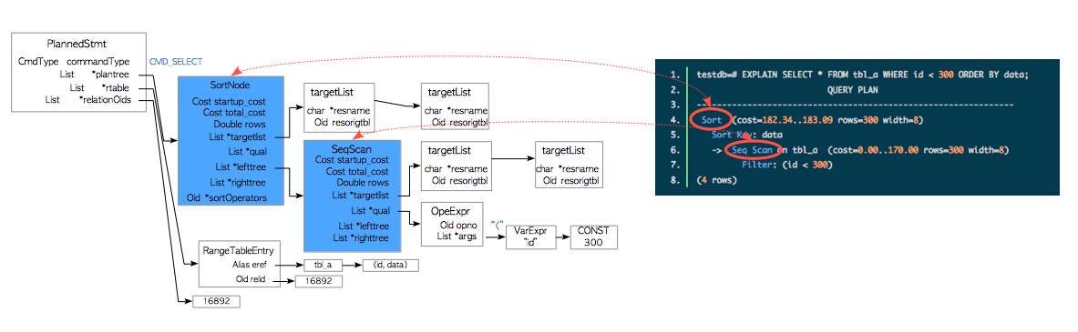

**Nodes**

The first thing to understand is that each indented block with a preceeding “->” (along with the top line) is called a node. A node is a logical unit of work (a “step” if you will) with an associated cost and execution time. The costs and times presented at each node are cumulative and roll up all child nodes.

**Cost**:

It is not the time but a concept designed to estimate the cost of an operation. The first number is start-up cost (cost to retrieve first record) and the second number is the cost incurred to process entire node (total cost from start to finish).

Cost is a combination of 5 work components used to estimate the work required: sequential fetch, non-sequential (random) fetch, processing of row, processing operator (function), and processing index entry.

**Rows** are the approximate number of rows returned when a specified operation is performed.

(In the case of select with where clause rows returned is

Rows = cardinality of relation * selectivity )

**Width** is an average size of one row in bytes**.**

**Explain Analyze command:**

The EXPLAIN ANALYZE option causes the statement to be actually executed, not only planned. Then actual run time statistics are added to the display, including the total elapsed time expended within each plan node (in milliseconds) and the total number of rows it actually returned. This is useful for seeing whether the planner's estimates are close to reality.

Ex: EXPLAIN (ANALYZE) SELECT * FROM foo;

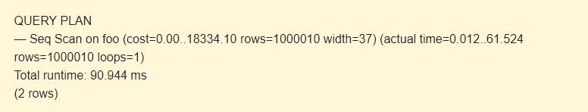

The command displays the following additional parameters:

* **actual time** is the actual time in milliseconds spent to get the first row and all rows, respectively.
* **rows** is the actual number of rows received with Seq Scan.
* **loops** is the number of times the Seq Scan operation had to be performed.
* **Total runtime** is the total time of query execution.

Query plans for select with where clause can be sequential scan, Index Scan, Index only Scan, Bitmap Index Scan etc.

Query plans for joins are Nested loop join, Hash join, Merge join etc.

**Implementation Screenshots :**

**Comprehend how indexes improves the performance of query applied for your database . Demonstrate for the following types of query on your database**

* 1. **Simple select query**

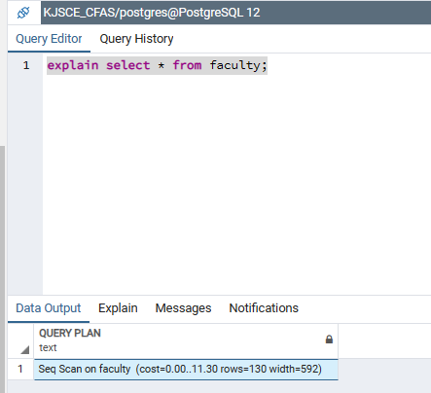

* 1. **Select query with where clause**

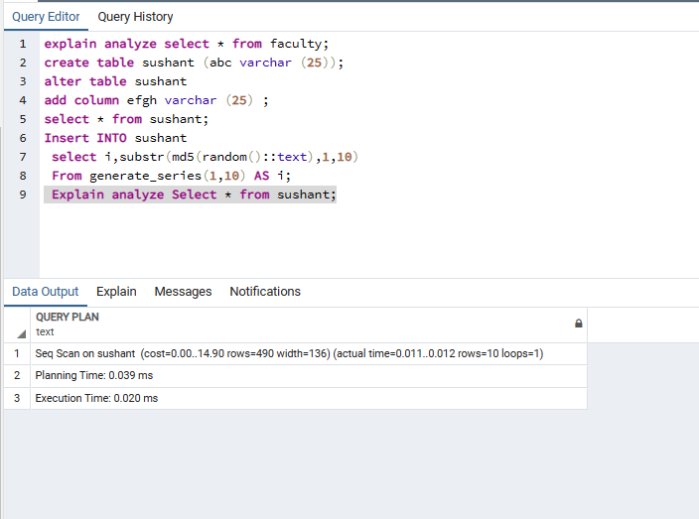

* 1. **Select query with order by query**

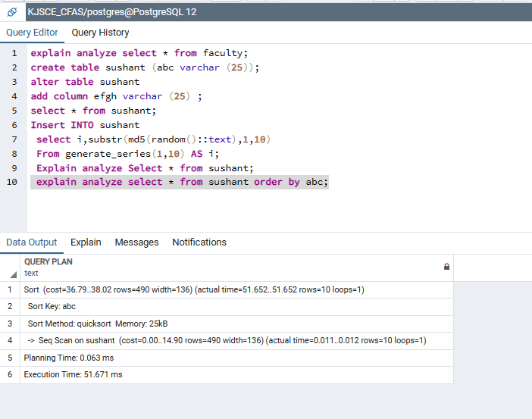

* 1. **Select query with JOIN**

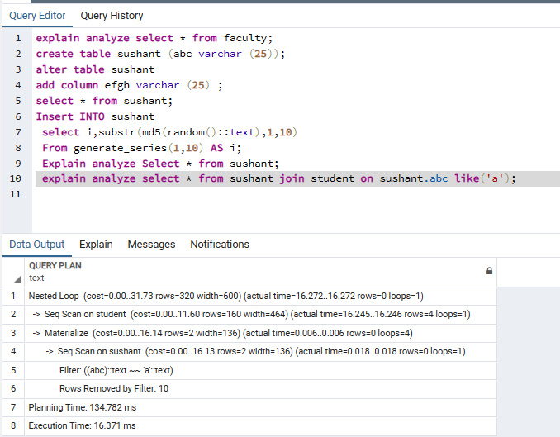

* 1. **Select query with aggregation**

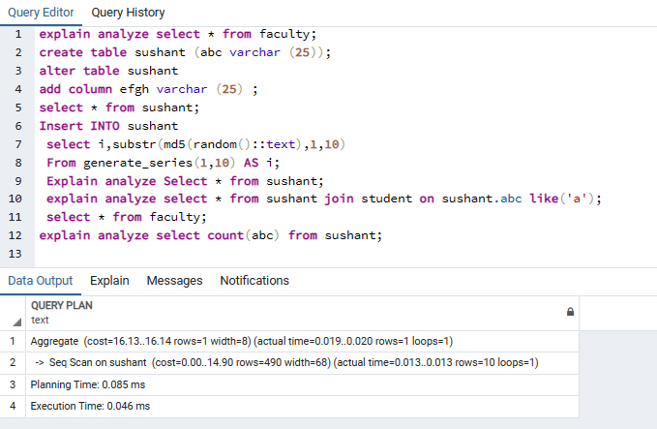

**Post Lab Question:**

1. **Illustrate with an example Heuristic based query optimization with suitable example**
2. Heuristic-based query optimization is a technique used by database management systems to optimize queries based on a set of predefined rules or heuristics. These rules are used to guide the query optimizer in selecting the most efficient execution plan for a given query.
3. The database optimizer has to decide on an execution plan for this query that is both efficient and effective. Here is an example of how heuristic-based optimization might work:
4. **Rule-based optimization:** The query optimizer applies a set of rules to optimize the query. For example, the optimizer may first apply the rule that filtering should be done before joining tables. This would involve applying the WHERE condition to the customers table before joining with the orders table. This reduces the size of the intermediate result set and improves performance.
5. **Cost-based optimization:** The query optimizer may then calculate the cost of executing the query using different execution plans. The optimizer estimates the cost of each plan based on statistics about the data in the tables and the execution times of different operators. The optimizer then chooses the plan with the lowest cost.
6. **Memoization:** The optimizer can store the execution plan for a query to avoid recalculating it in the future. This can save time and improve performance, especially for complex queries.

# Conclusion:

In this experiment we understood the concept of Indexing and Query processing in SQL and were able to implement it in PostgreSQL.